Dimensional Modeling Practice:
E1. UsedCarInc is a used car dealer. When a customer arrive with a car to sell, a dealer agent inspects the car and makes an offer to purchase the car. After purchasing, the car is cleaned and is made available for sale to other customers who come to buy used cars. Any dealer agent can be involved in either the purchase or sale process. Develop a dimensional model to support their main car purchase and sale process. A car purchase by dealer transaction includes information on the seller, dealer agent (employee), car, purchase price, and date. A car sale by dealer includes information on buyer, car, dealer agent (employee), sale price, and date. The company wants to increase profit (sale price minus purchase price) and have higher profit margins, and lower the number of days between car purchase by dealer and car sold by dealer (increase inventory turnover).
- What is the business process of interest here?
- What are the different levels of granularity present?
- What are the dimensions for each grain identified in #2?
- What are the facts for each grain in #2 ?
- Specify if VIN Number and Mileage are included in the model and the most appropriate table where they can be included
- Would an accumulating fact table apply in this case?

E2. SunDucks coffee has coffee shops in multiple states. They sell coffee, snacks and related products. You have been provided the following dimensional model for Sales process of SunDucks Coffee, built for the granularity of 1 row per transaction. Identify (1) errors or issues with the model, (2) potential problems due to the errors and (3) propose revisions to correct the errors.
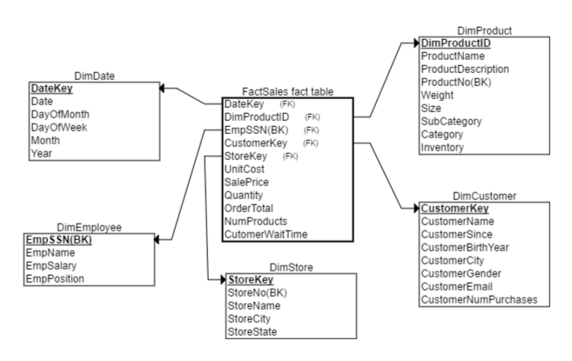
DimProduct
DimProductID | Primary key, sequentially generated
ProductName  ProductDescription | Name of product  Description of Product
ProductNo | Business Key
Weight | Product Weight
Size | Product size
SubCategory | Product Sub-cateogry
Category | Product category
Inventory | Number of product in company inventory
DimCustomer
CustomerKey | Primary key, sequentially generated
CustomerName | Name of Customer
CustomerSince | Date of first purchase
CustomerBirthYear | Year of Birth of customer
CustomerCity | Customer City of residence
CustomerGender | Customer gender
CustomerEmail | Customer email
CustomerNumPurchases | Number of purchases made by customer to date
DimStore
StoreKey | Primary key, sequentially generated
StoreNo | Business key
StoreName | Name of store
StoreCity | City in which store is located
StoreState | State in which store is located
DimEmployee
EmpSSN | Employee SSN, Primary Key, Business Key
EmpName | Name of Employee
EmpSalary | Salary of Employee
EmpPosition | Position of Employee
FactSales
UnitCost | Unit cost of product sold
SalePrice | Price at which product was sold
Quantity | Quantity of a product sold ( for e.g. two regular coffees)
OrderTotal | Total price of all products sold
NumProducts | Total number of products sold in order (for e.g. 3 products coffee, cookies and bottled water)
CustomerWaitTime | Total time waited by customer to receive all products in order

